autonet examples

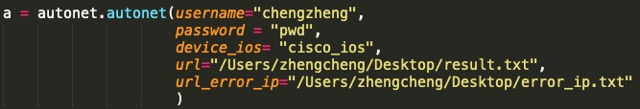

username: your username used for logging on the device

password: password for the username. It’s recommended to use getpass.getpass to hide the echo.

device_ios: the ios of network device. So far autonet support cisco_ios, cisco_nxos, rg_os.

I will add more ios later or if you have special requirement, kindly contact me via [zc8131868@gmail.com](mailto:zc8131868@gmail.com).

url: you can find the result file via the URL input here.

url_error_ip: you can find the problematic ip addresses via the URL input here.

*Note: if you don’t need the files, you can leave both attributes empty. Autonet support both telnet and ssh and can identify the pattern automatically.*

1. PING_IP



ip: a list of target ip addresses



You can test the reachability of single ip or a group of ip.



This method returns a dictionary with keys reachable and unreachable and the corresponding value is a list containing ip.

1. PING_Subnet



subnet: a subnet, eg: 192.20.32.0/18.



You can test reachability of the ip of the given subnet.

*Note: Ping_Subnet use threads to test reachability. No matter how many ip you need to test, the speed is almost as the same as testing single ip in theory.*

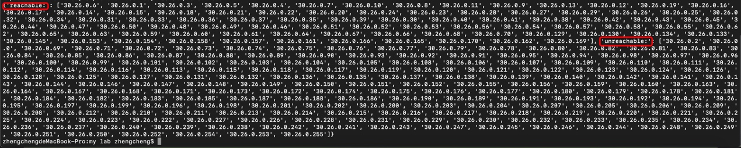

1. auto_show

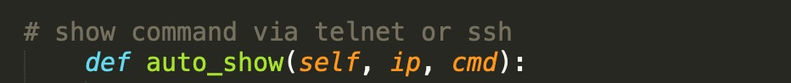

ip: single ip address.

cmd: single show cmd.



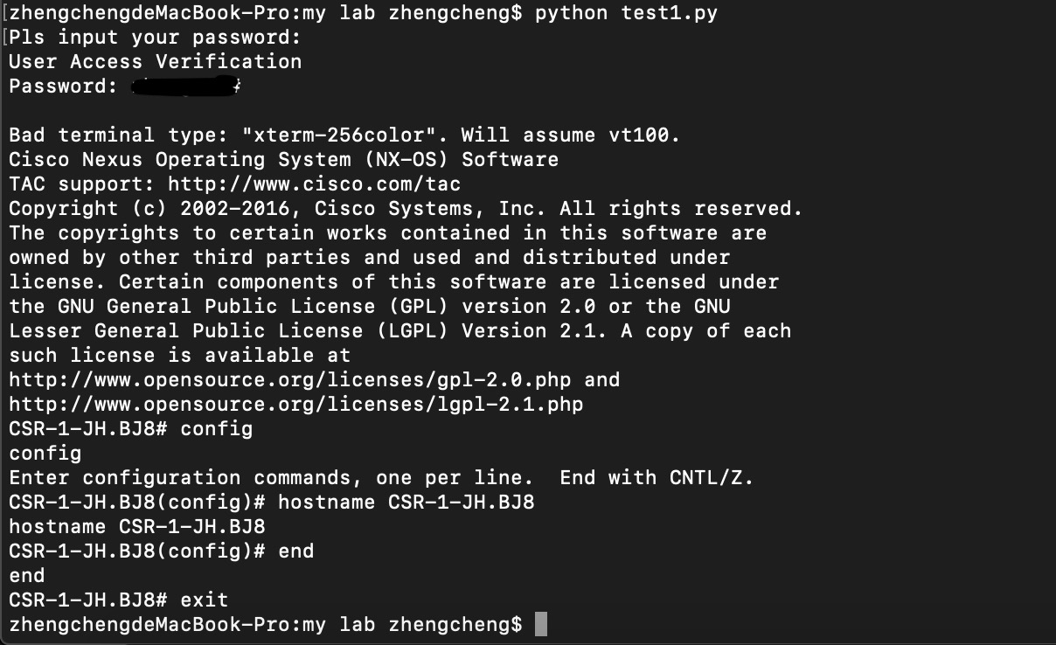

You can find the log file without password revealed where you want to place.

1. auto_config

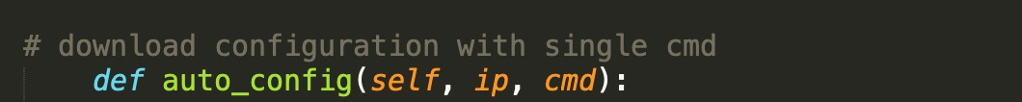

ip: single ip address

cmd: a list of commands



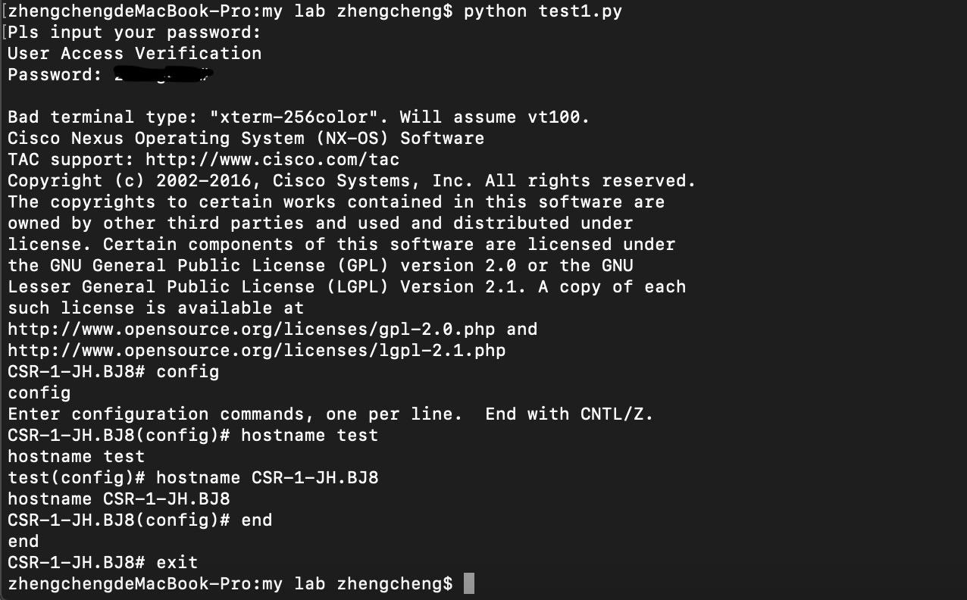

1. auto_config_file



ip: single ip address

file: file contains commands



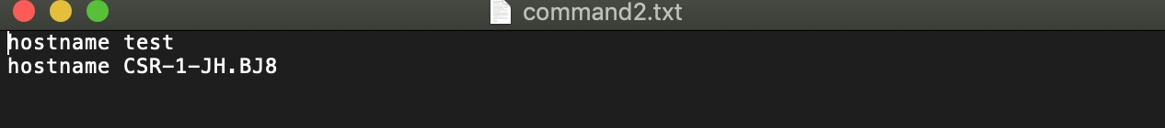

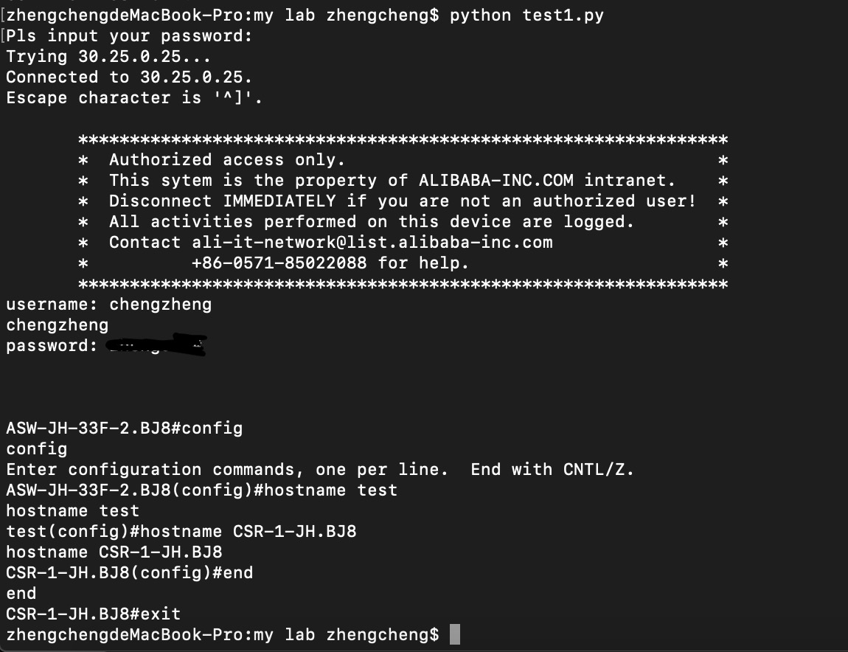

1. get_serial_number

This method returns a list of desired serial number(s).



ip: single ip address





For stacked switches:

RG_OS S5750-48GT/4SFP-P



Cisco_IOS WS-C3750-48P

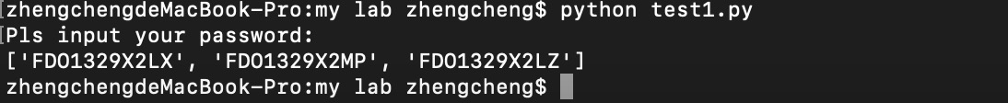

*Note: due to some cisco ios devices like C4500, C6500 are out of date and rarely deployed massively. This method doesn’t provide the check function or you can use auto_show to get the serial number.*

1. get_version

This method returns a list of system soft version.



ip: single ip address

